

OOP Lab #1
SUBMITTED BY:
UBAID AHMAD
ROLL NO:
2410-0011
SUBMITTED TO:
Mam Laiba Tanveer
DATE:
23/09/2025

Example Task
Code:
#include <iostream>
using namespace std;
class Car{
public:
string model;
int price;
string color;
long year;
void start(){
cout<<"Car is started!"<<endl;
}
void carModel(){
cout<<this->model<<endl;
}
};
int main(){
Car c1;
c1.start();

c1.model="2025";
c1.carModel();
return 0;

}

Output:
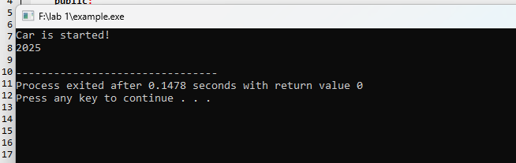

Task 1
Code:
#include <iostream>
using namespace std;
class Shape{
public:
string Color;
string ShapeName;

double Area(double length,double width){
double area=length*length;
return area;
}

};
int main(){
Shape s1;
s1.ShapeName="square";
s1.Color="green";
double area=s1.Area(4,7);
cout<<area<<endl;
return 0;
}

Output:
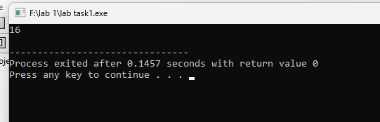

Task 1.2 user input
Code:
#include <iostream>
using namespace std;
class Shape{
public:
string Color;
string ShapeName;
double length;
double width;

void getData(){
cout<<"Enter the shape Name : ";
cin>>this->ShapeName;
cout<<"Enter the shape color: ";
cin>>this->Color;
cout<<"Enter the shape length: ";
cin>>this->length;
cout<<"Enter the shape width: ";
cin>>this->width;

}
double Area(){
double area;
if(this->ShapeName=="square"){
area=this->length*this->length;

}
else if(this->ShapeName=="rectangle"){
area=this->length*this->width;
}
else if(this->ShapeName=="circle"){
area=3.14*(this->length*this->length);
}
else{
cout<<"the shape is invalid!"<<endl;
}
return area;
}
};
int main(){
Shape s1;
s1.getData();
double area=s1.Area();
cout<<"Area of the "<<s1.ShapeName<<"is: "<<area<<endl;
return 0;
}
OutPut:
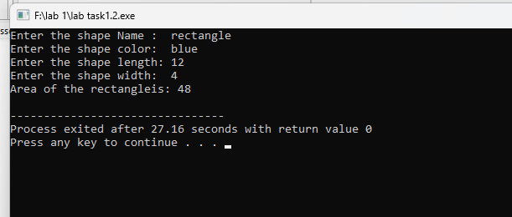
Task 2
Code:
#include <iostream>
using namespace std;
class Car{
public:
string model;
int price;
string color;
long year;

void start(){
cout<<"Car is started!"<<endl;

}

void carModel(){
cout<<this->model<<endl;
}

void printDetails(){
cout<<"model is: "<<this->model<<endl;
cout<<"year is: "<<this->year<<endl;
cout<<"price is: "<<this->price<<endl;
cout<<"color is: "<<this->color<<endl;
}
};
int main(){
Car c1;
c1.start();

c1.model="2015";
c1.color="black";
c1.price= 25000;
c1.year=2025;
c1.printDetails();
return 0;

}
Output:
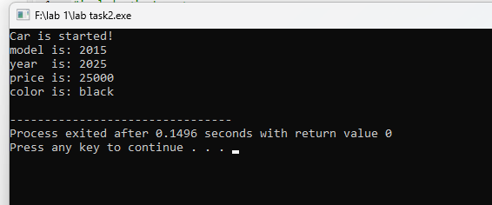
Task 3
Code:
#include <iostream>
using namespace std;
class Student{
public:
string name;
int rollNo;
int marks;
void getDetails(){
cout<<"Enter Student name: ";
cin>>this->name;
cout<<"Enter Student RollNo: ";
cin>>this->rollNo;
cout<<"Enter Student marks: ";
cin>>this->marks;
}
void printDetails()
{
cout<<"Student Name is: "<<this->name<<"\nStudent Roll Number is: "<<this->rollNo<<"\nStudent marks are: "<<this->marks<<endl;
}
};

void function(){
Student s1,s2;
cout<<"------------------------Enter Data for Student 1!\n"<<endl;
s1.getDetails();`
cout<<"\n------------------------Enter Data for Student 2!\n"<<endl;
s2.getDetails();
cout<<"\n-----------------------student1: Details;"<<endl;
s1.printDetails();
cout<<"\n------------------------student2: Details;"<<endl;
s2.printDetails();
}
main(){
function();
return 0;
}

OutPut:
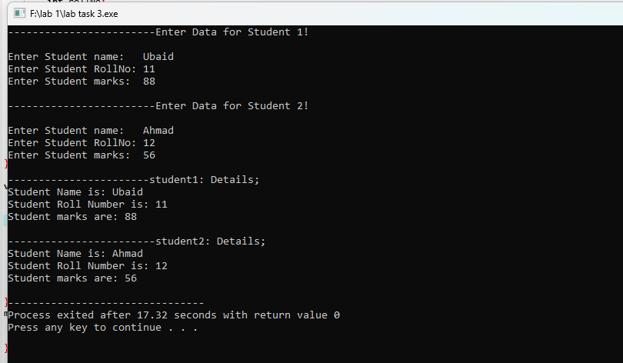

Task 3
#include <iostream>
using namespace std;
class Student{
public:
string name;
int rollNo;
int marks;
void getDetails(){
cout<<"Enter Student name: ";
cin>>this->name;
cout<<"Enter Student RollNo: ";
cin>>this->rollNo;
cout<<"Enter Student marks: ";
cin>>this->marks;
}
void printDetails()
{
cout<<"Student Name is: "<<this->name<<"\nStudent Roll
N umber is: "<<this->rollNo<<"\nStudent marks are: "<<this-
>marks<<endl;
}
};

void function(){
int size;
cout<<"how many Objects do you want to create: "; //user can decide how many objects he wants
cin>>size;
Student s[size];
for(int i=0;i<size;i++){
cout<<"\n------------------------Enter Data for Students: "<<i+1<<endl;
s[i].getDetails();
}

for(int i=0;i<size;i++){
cout<<"\n-----------------------student "<<i+1<<": Details;"<<endl;
s[i].printDetails();
}

}
main(){
function();
return 0;
}
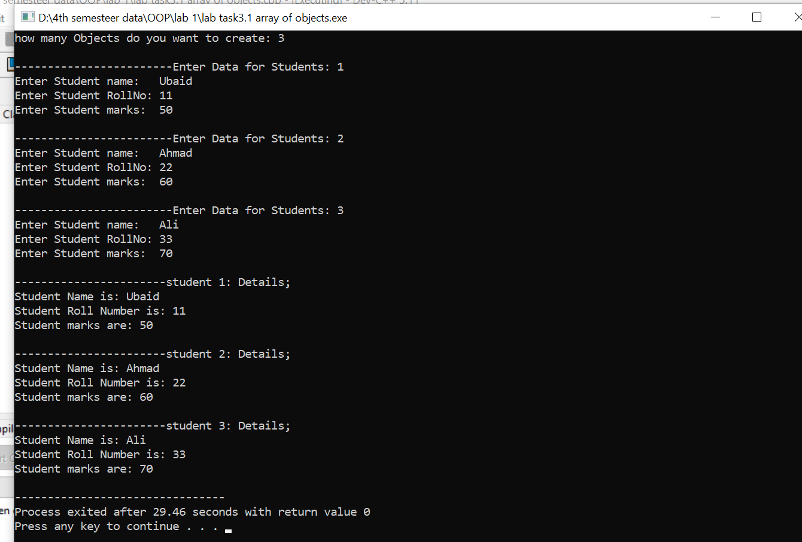
End,,,

